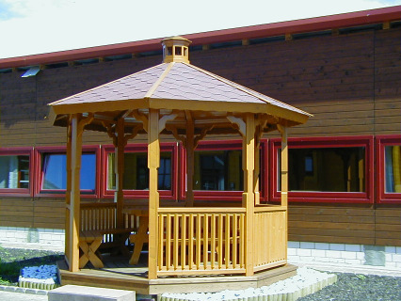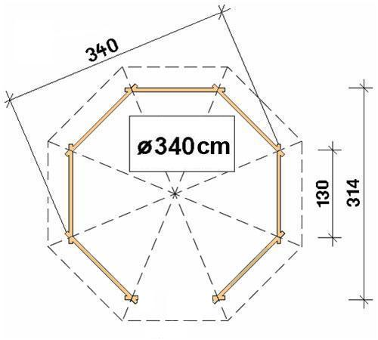

Kaunas Pavilion
Roof projection: 0.30 m
Diameter: 3.40 m

Consisting of:

Floor: 8 pre-mounted, base sections with 40mm planks.
Roof: 8 roof sections made from 20 mm tongue and groove boards.
Sides: 8 posts, 7 pre-mounted balustrade sections and 8 pre-mounted roof pelmet
sections.

£1675

Optional Extras:

Roof Shingles: Call for Price
Furniture: £505
(7 benches, 1 table)

